## Darshan Nikam Date: 28/02/2024

**Amazon Machine Image ( AMI )**

*Amazon Machine Image (AMI)* in AWS (Amazon Web Services) is a pre-configured virtual machine image, which is used to create instances (virtual servers) in the Amazon Elastic Compute Cloud (EC2). AMIs provide a base operating system, application server, and applications that you can use to quickly deploy and run applications in the cloud.

You can launch multiple instances of an AMI, as shown in the following figure.


     Launch multiple instances from an AMI.
    

Your instances keep running until you stop, hibernate, or terminate them, or until they fail. If an instance fails, you can launch a new one from the AMI.

Amazon Web Services (AWS) publishes many [Amazon Machine Images (AMIs)](https://docs.aws.amazon.com/AWSEC2/latest/UserGuide/finding-an-ami.html) that contain common software configurations for public use. In addition, members of the AWS developer community have published their own custom AMIs. You can also create your own custom AMI or AMIs; doing so enables you to quickly and easily start new instances that have everything you need. For example, if your application is a website or a web service, your AMI could include a web server, the associated static content, and the code for the dynamic pages. As a result, after you launch an instance from this AMI, your web server starts, and your application is ready to accept requests.

All AMIs are categorized as either backed by Amazon EBS, which means that the root device for an instance launched from the AMI is an Amazon EBS volume, or backed by instance store, which means that the root device for an instance launched from the AMI is an instance store volume created from a template stored in Amazon S3.

**Instances**

An instance is a virtual server in the cloud. Its configuration at launch is a copy of the AMI that you specified when you launched the instance.

You can launch different types of instances from a single AMI. An *instance type* essentially determines the hardware of the host computer used for your instance. Each instance type offers different compute and memory capabilities. Select an instance type based on the amount of memory and computing power that you need for the application or software that you plan to run on the instance

**Now we create our Custom AMI.**

**We have already launched the Ec2 Instance with Amazon AMI, and we created a user and some directories and files then we installed the httpd package and hosted static web into our instance. Now we say this is our custom server and whenever we start new work or a project we need these configurations and these web servers, web pages whatever we configured. So next we don’t want to do the same things again and again that’s why we create our pre-configured servers or webpages whatever we have created in this instance, we simply create AMI of this instance by following the steps:**

**Step 1)** Go to your Ec2 Instance Dashboard, and select your pre-configured Instance.

**Step 2)** Click on the Action button and select the Image and template option, And Click on Create Image Button.

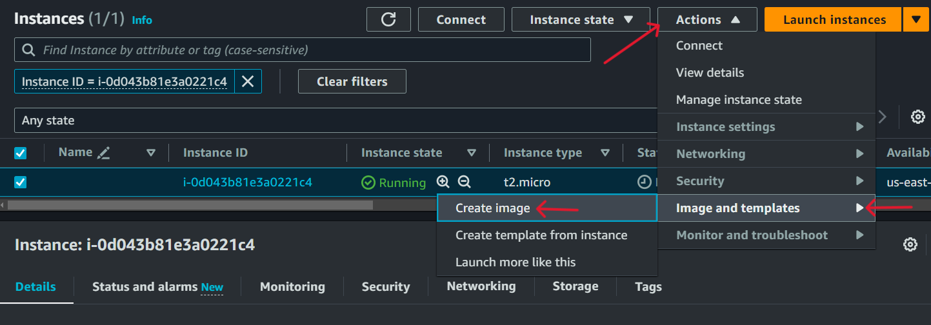

**Step 2)** Enter AMI name, and click on Create Image Button, (go with default volume or if needed you add more volume)

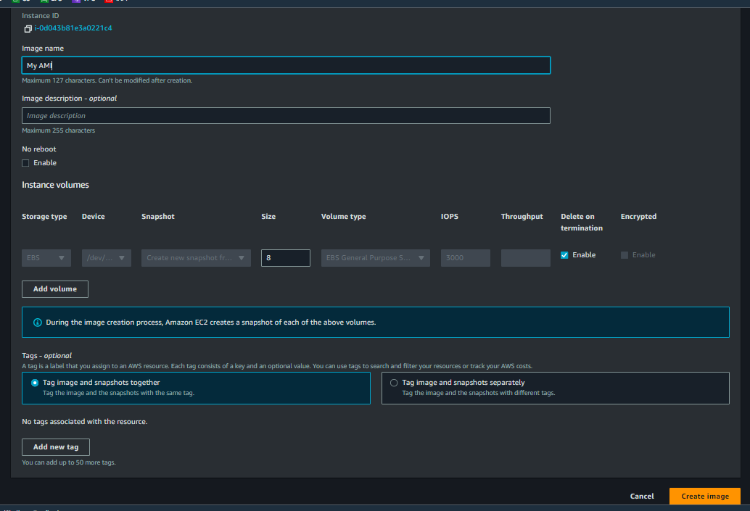

**Now your Custom AMI is created, go to Images Menu and click on AMIs where you can see you’re AMI.**

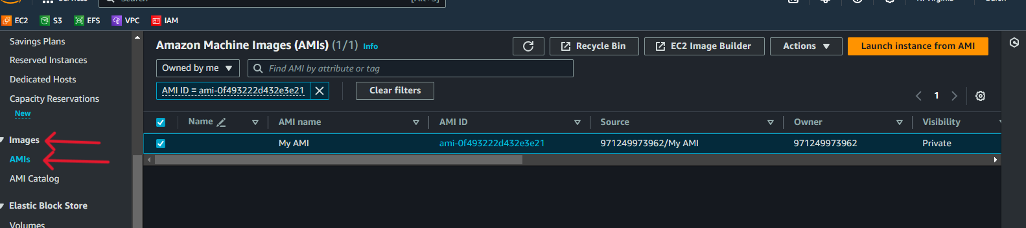

**Also snapshot will be created of AMIs, which is the root volume of your AMI, which stores the custom AMI all data that you have configured and when you launch a new Instance using your custom AMI then this snapshot comes in role.**

